DATA SCIENCE INTERNSHIP
WEEK 3
PYTHON-BASED MACHINE LEARNING MODEL DEVELOPMENT AND EVALUATION PLAN

Prepared by: Ankit Kumar

INTRODUCTION
Machine Learning is an important part of Data Science that helps computers learn from past data and use that learning to make predictions or support better decisions. Instead of making every decision manually, a machine learning model can identify patterns in historical data and use those patterns to predict what may happen in the future.
In this Week 3 project, the focus is on developing a Python-based machine learning plan for predicting future sales of a retail business. Sales prediction is an important business activity because companies need to understand how much they may sell in the future. Better sales predictions can help a business plan inventory, manage resources, avoid unnecessary stock, prepare for changes in customer demand, and make better business decisions.
The project explains the complete process of developing a machine learning model, starting from defining the business problem and understanding the available data. The next steps include data preprocessing, feature selection, model selection, model training, model evaluation, model validation, and model deployment. Each step has an important role in making the final model useful and reliable.
Data preprocessing is required to make the data suitable for analysis and machine learning. It may include handling missing values, removing duplicate records, correcting inconsistent information, and converting data into a suitable format. After preparing the data, important variables that may influence sales are identified and selected.
Different machine learning models can then be considered and compared based on their suitability for the sales prediction problem. The selected model would be trained using historical sales data and evaluated using suitable performance measures such as MAE, MSE, and RMSE. Model validation is also important because it helps check whether the model can perform well on data that it has not seen before.
Finally, the project explains how the model could be deployed in a real business environment and monitored over time. Since customer behaviour, market conditions, and sales patterns can change, the model may need to be updated or retrained using newer data.
Overall, this project provides a structured and practical understanding of how machine learning can be used to solve a real-world business problem. It also connects technical concepts such as machine learning and data analysis with business requirements such as forecasting, planning, and decision-making.

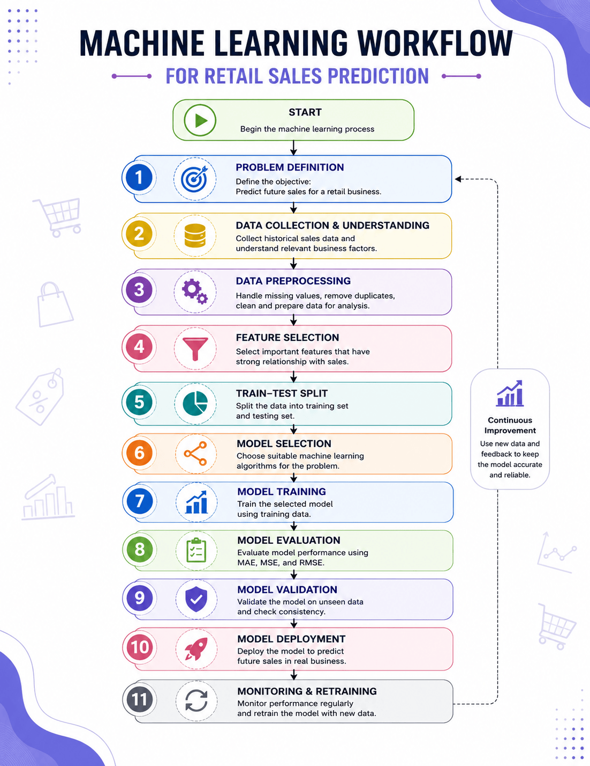

PROBLEM DEFINITION
The hypothetical business problem selected for this project is sales prediction for a retail business. In a retail business, sales can change from time to time depending on customer demand, product performance, season, pricing, promotions, and other business factors. Because of this, it can be difficult for a business to accurately estimate how much it will sell in the future.
The main objective of this project is to develop a machine learning model that can predict future sales using historical sales data and other relevant business information. The idea is to use the information from the past to understand sales patterns and then use those patterns to make better predictions about future sales.
For example, if a retail store has sales data from previous months or years, the data may show that certain products sell more during particular periods. Similarly, some products or regions may consistently generate higher sales than others. By studying these patterns, a machine learning model can learn from previous observations and provide an estimate of future sales.
Accurate sales prediction can be useful for the business in many ways. It can help management plan inventory, manage stock levels, allocate resources, prepare for customer demand, and make better business decisions. If the business expects higher demand, it can prepare sufficient stock in advance. On the other hand, if lower sales are expected, the business can avoid keeping unnecessary inventory.
This problem is suitable for machine learning because historical sales data may contain patterns and relationships that are difficult to identify manually. A machine learning model can analyse a large amount of historical information and learn from previous sales behaviour. The model can then use this learning to make predictions for new or future data.
However, simply building a model is not enough. The data first needs to be properly prepared by handling issues such as missing values, duplicate records, inconsistent information, and unnecessary variables. After preprocessing, important features will be selected and different machine learning models can be considered. The models will then be trained and compared to identify which approach provides reliable predictions.
The performance of the selected model will also be evaluated using suitable measures such as Mean Absolute Error (MAE), Mean Squared Error (MSE), and Root Mean Squared Error (RMSE). Model validation will be used to check whether the model performs well not only on the data it has learned from but also on new and unseen data.
The overall aim is therefore to create a structured plan for a sales prediction model that is accurate, reliable, and useful from a business point of view. This project connects machine learning concepts with a practical business requirement—helping a retail business use its historical data to make more informed decisions about future sales.

DATA PREPROCESSING
Data preprocessing is one of the most important steps before building a machine learning model. In simple terms, it means cleaning and preparing the available data so that the machine learning model can understand and use it properly. In a real business situation, the data collected from different sources may not always be perfect. It can contain missing values, duplicate records, incorrect information, or variables that are not useful for the analysis.
For this project, the historical sales data will first be studied to understand its structure, variables, data types, and overall quality. This initial understanding is important because it helps identify what kind of problems are present in the dataset and what steps are required before training the machine learning model.

1. Handling Missing Values
The first step will be to check whether any important information is missing from the dataset. For example, some records may not have sales values, product information, region, or other relevant details.
Missing values will be handled carefully depending on their importance and frequency. In some cases, records with very little missing information may be removed, while in other cases, suitable values may be used to fill the missing information. The aim is to avoid losing useful data while making sure that missing information does not negatively affect the model.

2. Removing Duplicate Records
The dataset will also be checked for duplicate records. Sometimes the same sales transaction may appear more than once because of errors during data collection or data entry.
Duplicate records will be removed where necessary so that the same transaction does not get counted multiple times. This will help the model learn from accurate information.

3. Checking Inconsistent Data
The data will be checked for inconsistencies in values and formats. For example, the same region or product may have been entered using different names or formats.
Such inconsistencies will be corrected wherever necessary. This will make the dataset more organised and easier to analyse.

4. Handling Numerical Variables
Numerical variables may have very different ranges. For example, sales amount could be in thousands while another variable may have much smaller values.
Depending on the machine learning algorithm selected, numerical variables may be standardized or normalized. This can help the model work more effectively when variables have very different scales.

5. Converting Categorical Data
Some information in the dataset may be categorical rather than numerical. For example, product category, region, or sales channel may contain text values.
Since most machine learning algorithms work with numerical data, these categorical variables may need to be converted into a suitable numerical format using encoding techniques.

6. Feature Selection
Not every variable in the dataset will necessarily be useful for predicting sales. Therefore, the available variables will be studied to identify the factors that have a meaningful relationship with sales.
For example, factors such as product category, region, price, quantity sold, and previous sales may provide useful information for predicting future sales, depending on what is available in the dataset.
Unnecessary or repetitive variables will be removed where appropriate. This can make the model simpler and reduce unnecessary complexity.

7. Identifying Outliers
The dataset will also be checked for unusual values or outliers. For example, if most daily sales are between ₹10,000 and ₹50,000 but one record shows ₹5,00,000, it should be investigated.
An unusual value does not always mean that it is wrong. It could represent a genuine high-sales day. Therefore, outliers will be reviewed carefully rather than automatically removed.

8. Preparing Data for the Model
After completing the cleaning and preparation process, the final dataset will be divided into suitable training and testing data. The training data will be used by the model to learn patterns, while the testing data will later be used to check how well the model performs on new data.
Overall, the purpose of data preprocessing is to turn raw business data into clean, organised, and useful information for machine learning. Good preprocessing can improve the quality of the analysis and help the model produce more reliable sales predictions.

MODEL SELECTION AND TRAINING
After the data has been properly cleaned and prepared, the next step is to decide which machine learning model should be used to predict future sales. Model selection is important because different models learn patterns in different ways. A model that works well for one business problem may not always give the same results for another problem.
For this project, the main objective is to predict future sales for a retail business. Therefore, regression-based machine learning models will be considered because the expected output is a numerical value, such as the predicted amount of sales.

1. Considering Different Models
Before selecting the final model, different suitable models can be considered and compared.
Linear Regression can be used as a simple starting or baseline model. It can help us understand whether there is a basic relationship between factors such as price, quantity, or previous sales and the final sales value. It is also relatively easy to understand and explain.
Decision Tree Regression can also be considered because sales may not always follow a simple straight-line relationship. A decision tree can identify different conditions and relationships within the data and can capture more complex patterns.
Ensemble methods can also be considered. These methods combine the results of multiple models or decision trees to improve prediction performance. They may provide better results when the sales data contains more complicated patterns.

2. Comparing the Models
The models will not be selected simply because one model is more advanced than another. Instead, their performance will be compared using suitable evaluation measures such as MAE, MSE, and RMSE.
The model that gives more reliable predictions with lower prediction errors will be considered more suitable for the problem.
At the same time, the model should not be unnecessarily complicated. A model that provides good accuracy while remaining reasonably simple and understandable can be more useful from a business point of view.

3. Training the Selected Model
Once the most suitable model is identified, it will be trained using the training dataset prepared during the data preprocessing stage.
During training, the model looks at the historical sales data and tries to understand the relationship between the input variables and the sales value.
For example, the model may learn how changes in product category, price, quantity, region, or previous sales are related to the final sales amount, depending on which variables are available in the dataset.
The main idea is simple: the model learns from past sales so that it can make predictions about future sales.

4. Hyperparameter Tuning
After creating the initial model, its settings can be adjusted to improve its performance. This process is called hyperparameter tuning.
For example, a Decision Tree model has settings that control how large or complex the tree can become. Trying different settings can help find a better balance between accuracy and complexity.
The purpose of tuning is not simply to make the model perform perfectly on the training data. Instead, the aim is to find settings that allow the model to perform well on new and unseen data.

5. Final Model Selection
After training and comparing the different models, the model with the most reliable performance will be selected for further validation.
The final decision will consider:
- Prediction accuracy
- MAE, MSE, and RMSE results
- Performance on unseen data
- Model complexity
- Suitability for the retail business problem
The selected model can then move to the model validation and deployment stages.

In very simple words:
Try different models → Linear Regression, Decision Tree, Ensemble methods
⬇️
Train the models → Let them learn from historical sales data
⬇️
Compare performance → Check which model makes fewer errors
⬇️
Tune the model → Adjust its settings to improve performance
⬇️
Choose the best model → Select the model that is accurate, reliable, and reasonably simple
⬇️
Move to validation → Check whether it works well on new data

EVALUATION METRICS
After training the machine learning models, the next important step is to check how well they are actually performing. Just because a model gives predictions does not mean that the predictions are accurate. We need some simple ways to compare the model's predicted sales with the actual sales.
These measures are called evaluation metrics. They help us understand how much difference there is between what the model predicted and what actually happened.
Since our project is about predicting sales, the output is a numerical value. Therefore, regression evaluation metrics will be used.

1. Mean Absolute Error (MAE)
MAE tells us the average difference between the actual sales and the sales predicted by the model.
For example, if the model predicts ₹50,000 but the actual sales are ₹55,000, the difference is ₹5,000. MAE looks at these differences across all the predictions and calculates their average.
The smaller the MAE, the better the model is performing.

2. Mean Squared Error (MSE)
MSE also measures the difference between actual and predicted sales. However, it squares the errors before calculating the average.
Because the errors are squared, larger mistakes receive more importance.
For example, a prediction that is slightly wrong will have a smaller effect, while a very large prediction error will have a much bigger effect on the MSE.
A lower MSE generally indicates better model performance.

3. Root Mean Squared Error (RMSE)
RMSE is calculated by taking the square root of MSE. One useful feature of RMSE is that it is expressed in the same unit as the sales value, which makes it easier to understand from a business perspective.
For example, if the RMSE is ₹8,000, it gives us an idea of the typical size of prediction errors in terms of sales.
A lower RMSE indicates that the model's predictions are closer to the actual values.

4. Comparing Different Models
These metrics will be used to compare the different models considered in the project.
For example:
MODEL | MAE | MSE | RMSE
Linear Regression | Lower | Lower | Lower
Decision Tree | Medium | Medium | Medium
Ensemble Model | Lowest | Lowest | Lowest

MODEL VALIDATION
After training a machine learning model, we need to check whether it will actually work well when it receives new data. A model may perform very well on the data it has already learned from, but that does not always mean it will perform equally well on new situations. Model validation helps us check this.
In simple words, model validation answers an important question:
“Has the model actually learned useful patterns, or has it simply memorized the training data?”

1. Dividing the Data
The available dataset will be divided into different parts.
The training data will be used to teach the model and help it learn the relationship between the input variables and sales.
The testing data will contain information that the model has not seen during training. This data will be used later to check how well the model can make predictions on new information.
For example, if we have historical sales data, we can use one portion to train the model and another portion to test its predictions.

2. Checking Model Performance
After training, the model will make predictions using the testing data.
These predictions will then be compared with the actual sales values. Evaluation measures such as MAE, MSE, and RMSE can be used to understand how close the predictions are to the actual results.
If the model performs well on the testing data, it gives us more confidence that it can work with new data.

3. Using Cross-Validation
Cross-validation can also be used to make the validation process more reliable.
In simple terms, instead of depending on only one division of the data, the available training data is divided into several smaller parts. The model is trained and tested using different combinations of these parts.
This gives us a better idea of whether the model performs consistently or whether its performance changes significantly depending on which data is used.

4. Checking for Overfitting
One important problem we need to look for is overfitting.
Overfitting happens when a model performs extremely well on the training data but performs poorly on new data. This means the model may have learned the training examples too closely instead of learning general patterns.
For example, a model may give very accurate predictions for the sales data it has already seen but make poor predictions for next month's sales.
If this happens, the model may need to be simplified or its settings may need to be adjusted.

5. Selecting a Reliable Model
The final model should not simply be the model that performs best on the training data. It should be a model that gives consistent and reliable results on unseen data.
The validation results will therefore be considered along with MAE, MSE, and RMSE while deciding whether the model is suitable for further use and possible deployment.

MODEL DEPLOYMENT
Once the machine learning model has been trained, evaluated, and validated, the next step is to think about how the model can actually be used in a real business situation. This stage is called model deployment.
In simple terms, deployment means taking the trained model from the development stage and making it available for actual use. In our project, the model is designed to predict future sales for a retail business. Once the model is ready, it could be used to provide sales predictions whenever new business data is available.

1. Using the Model for Sales Prediction
After deployment, the business can provide new information to the model, such as relevant product, sales, pricing, or other available business details. The model will use the patterns it learned from historical data to generate a sales prediction.
For example, if a business wants to estimate the expected sales for the coming period, it can provide the required information to the deployed model. The model can then provide an estimated sales value.
This can help managers make decisions based on data rather than relying only on assumptions or past experience.

2. How Deployment Can Help the Business
A deployed sales prediction model can be useful in several areas:
- Inventory planning: Helps decide how much stock may be required.
- Resource planning: Helps the business prepare people and resources according to expected demand.
- Purchasing: Can support decisions about when and how much to purchase.
- Business planning: Provides an estimate that can be considered while making future plans.
- Decision-making: Gives managers additional information to support their decisions.

3. Monitoring the Model
Deploying a model does not mean the work is finished.
Business conditions can change over time. Customer preferences, market conditions, product demand, prices, and competitors may change. Because of this, a model that performs well today may not perform equally well after several months.
Therefore, the model's performance should be checked regularly.
For example, the business can compare the model's predicted sales with the actual sales that eventually occur. If the difference becomes too large, it may be a sign that the model needs improvement.

4. Updating and Retraining the Model
As new sales data becomes available, it can be added to the existing dataset. The model can then be retrained using the newer information.
This allows the model to learn from recent customer behaviour and changing sales patterns.
For example, if customer demand changes significantly compared with previous years, using only old data may result in less accurate predictions. Retraining the model with recent data can help it stay relevant.

5. Overall, Purpose of Deployment
The main purpose of deployment is to make the machine learning model useful in the real business environment. A model is valuable not only because it can produce accurate predictions, but because those predictions can actually help people make better decisions.

